**GENDER PAY GAP**

***My redesign project is focused on gender pay gap in Australia. During my research I found that factors like******discrimination, childcare and industrial segregation drives the disparity between gender wages. But the data and visualizations are very scattered as shown below. My aim is to include useful information in a single visual to prove the same point and make a claim based on that visual.***

Various government policies took place in previous decade to strike balance between gender payrates. This visual shows the percent decrease or increase in the pay gap compared to previous year, based on industry. It is a very good visual if the aim is to show that we are heading in right direction with this problem. But it fails to explain the factors affecting the change, also no actions can be suggested based on mere its visual.

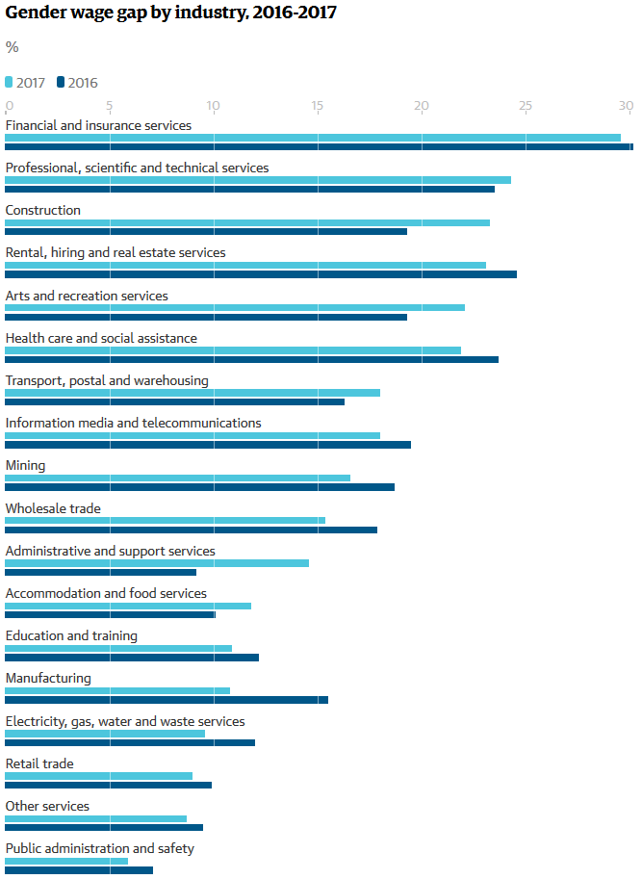

Reference: <https://www.theguardian.com/australia-news/datablog/2017/oct/18/australia-gender-pay-gap-why-do-women-still-earn-less-than-men>

<https://www.wgea.gov.au/addressing-pay-equity/what-gender-pay-gap>

**Causes of the gender pay gap**   
The gender pay gap is influenced by a number of [factors](https://www.wgea.gov.au/sites/default/files/wgea-business-case-for-gender-equality.pdf), including:

* discrimination and bias in hiring and pay decisions
* women and men working in different industries and different jobs, with female-dominated industries and jobs attracting lower wages
* women’s disproportionate share of unpaid caring and domestic work
* lack of workplace flexibility to accommodate caring and other responsibilities, especially in senior roles
* women’s greater time out of the workforce impacting career progression and opportunities.

<https://www.wgea.gov.au/sites/default/files/wgea-business-case-for-gender-equality.pdf>

**The business case for gender equality**

<https://www.theguardian.com/australia-news/datablog/2017/oct/18/australia-gender-pay-gap-why-do-women-still-earn-less-than-men>

**Australia's gender pay gap: why do women still earn less than men?**

**Gender wage gap by industry, 2016-2017**

<https://www.wgea.gov.au/sites/default/files/BCEC%20WGEA%20Gender%20Pay%20Equity%20Insights%202017%20Report.pdf>